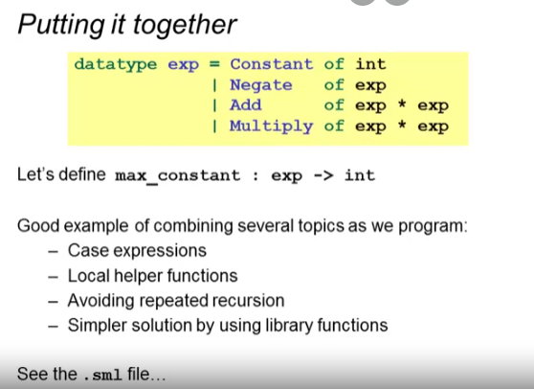

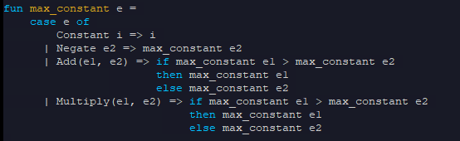











*Fixing max_constant*

Avoiding recomputation:

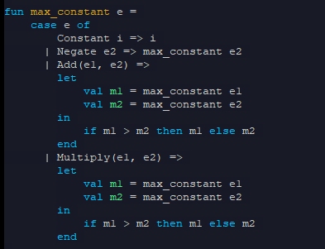

Avoiding copy pasting (duplicate codes)

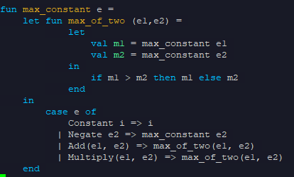

Using the Int.max (built-in function)

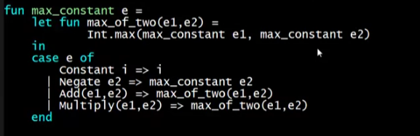

Then removing the local helper function since Int.max is not an expensive calculation

